**Hospital Healthcare Insights Report**

**This report presents an analysis of hospital patient records using an interactive dashboard designed in Power BI. The underlying dataset contains demographic, clinical, operational, and financial data, with information compiled from multiple healthcare institutions. The goal is to transform complex medical data into actionable insights for improved patient outcomes, smarter resource allocation, and cost-effective care.**

**1. Demographics Overview**

* The **average age** of admitted patients is **51.28 years**, indicating a significant portion of the hospital's patient base consists of middle-aged and older adults.
* The dashboard indicates a **balanced gender distribution**, confirming that the hospital serves a broad demographic.
* **Visualization Used**: **Donut and card visuals** provide at-a-glance metrics for key demographic indicators and facility capacity.

**2. Medical Condition Analysis**

* **Hypertension**, **Diabetes**, **Asthma**, **Obesity**, **Arthritis**, and **Cancer** are the most prevalent medical conditions among admitted patients.
* The dashboard reveals prescription volumes by condition (**Aspirin, Ibuprofen, Lipitor, Paracetamol, Penicillin**), helping clinicians and administrators track medication efficacy and demand.
* **Visualization Used: Clustered bar charts and tables** show patient volumes and medication usage across conditions and hospitals, making it easy to prioritize high-risk and high-cost groups.

**3. Resource Utilization**

* Beds/rooms in use are closely tracked, with the dashboard noting significant month-over-month changes (e.g., **↓88.2% vs 2022**), signaling possible seasonal or operational fluctuations.
* The dashboard map clearly **Hospital Locations**, enabling spatial analysis for patient distribution and emergency planning.
* 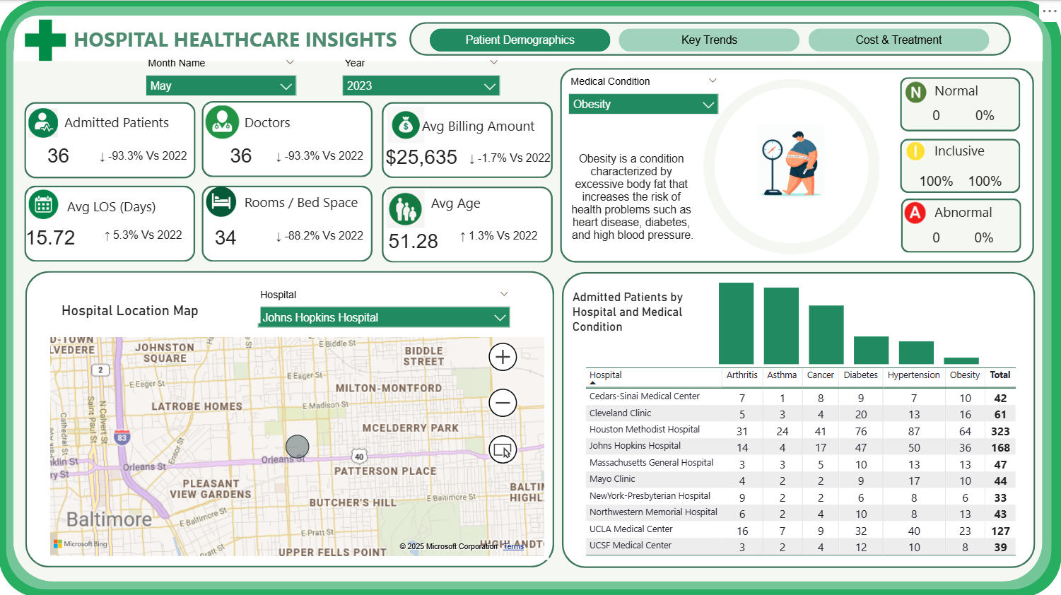**Visualization Used: Maps and facility cards** illustrate location and resource spread, guiding allocation decisions.

PATIENT DEMOGRAPHICS POWER BI DASHBOARD

**4. Financial Trends**

* Patients incur an average bill of **$25,635** (Obesity) or **$24,970** (Asthma), with trend lines indicating slight decreases compared to the previous year.
* **Visualization Used:** **Line graphs** in the dashboard break down billing trends by admission type (Elective, Emergency, Urgent), allowing financial controllers to **pinpoint spikes** and optimize discharge policies.

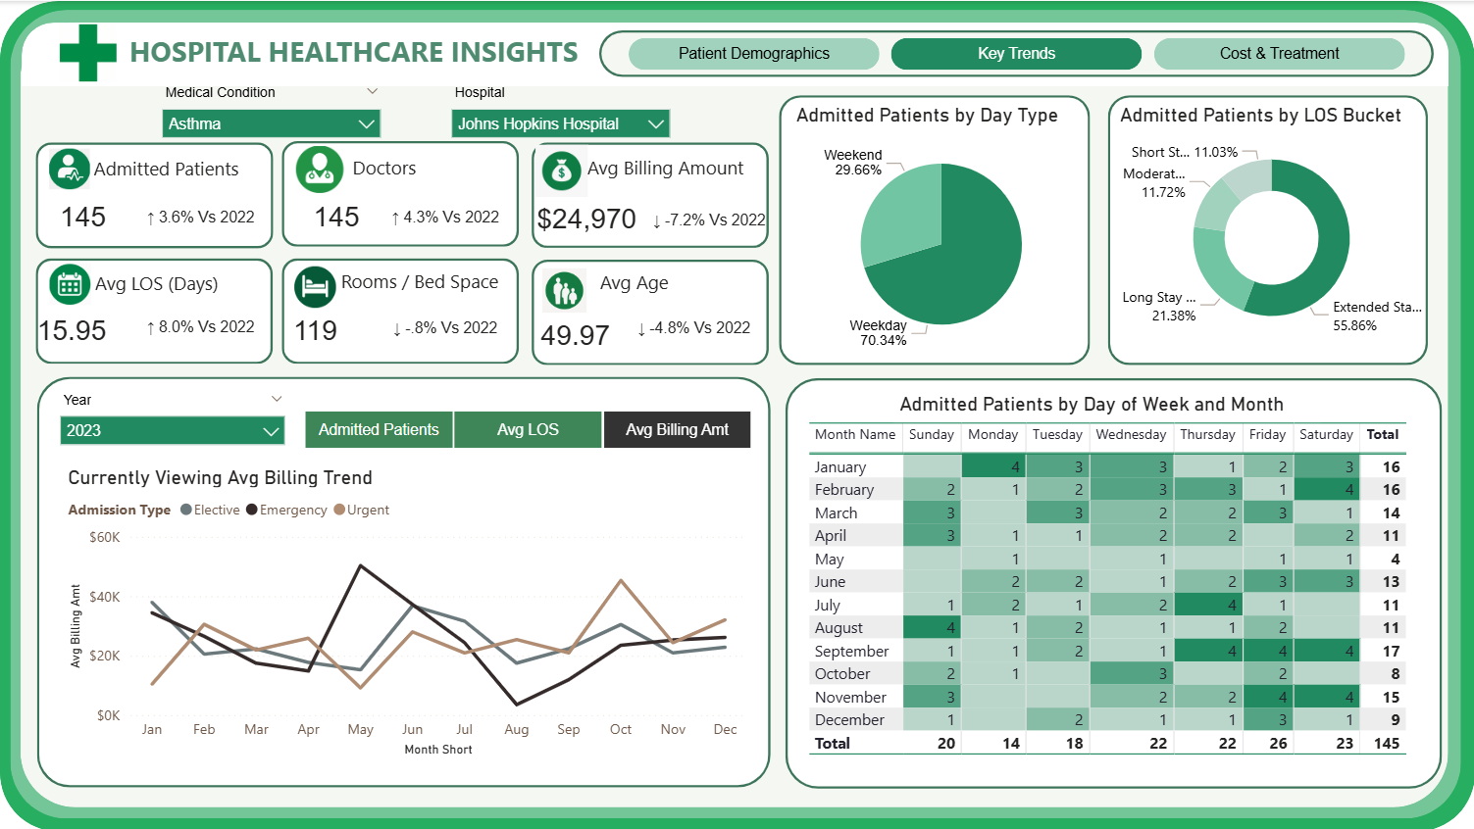 FINANCIAL KEY TRENDS POWER BI DASHBOARD

**5. Admissions & Discharge Patterns**

* **Average LOS:** 15.72 days (Obesity); 15.95 days (Asthma)
* Admissions are broken down by **weekday/ weekend** and **LOS buckets** (short, moderate, long, extended).
* **Visualization Used:** **Pie/donut** **charts** and **heatmaps** visualize when admissions occur, helping schedule resources and spot discharge bottlenecks.

**6. Cost & Treatment Patterns**

* Patients with extended stays generate the highest cumulative billing. **Elective and emergency admissions** present different cost profiles.
* **Diabetes, Hypertension**, and **Obesity** have the highest prescription volumes across all drug categories.
* **Visulaization Used: Bar column**, and **table visuals** aggregate cost and treatment dimensions for easy comparison.

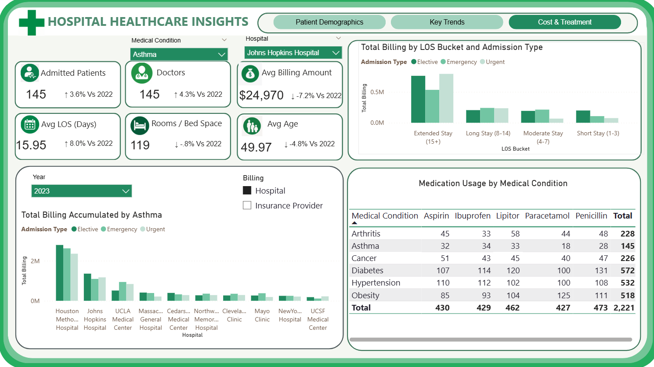COST AND TREATMENT POWER BI DASHBOARD

**7. Relationship Insights**

This dashboard serves as more than an analytical tool—it is a strategic asset in daily hospital management:

* Dashboard **filters quickly reveal** that chronic conditions like diabetes and hypertension usually result in **longer stays** and **higher billing**. This guides the prioritization of tailored care plans and prevention programs.
* Comparing **hospital performance** (admissions, costs, capacity) uncovers which facilities are under strain or which have opportunities for process improvement.
* Visualization of admissions by day and month allows managers to allocate staff and **beds during expected surges**, **minimizing delays or bottlenecks**.

**Short Story Behind the Dashboard**

This hospital healthcare dashboard was created to provide administrators and clinicians with clear, actionable insights drawn from complex data. For instance, the dashboard reveals that **55.86%** **of admitted patients** experience extended stays of **15 days** or more, which significantly impacts resource utilization and costs. Conditions like hypertension and diabetes, which account for approximately **48%** **of total admissions**, are major contributors to longer lengths of stay and higher billing amounts, underlining the need for dedicated management programs. By tracking admission patterns, the dashboard also shows that nearly **70% of patients are admitted** during weekdays, helping hospitals optimize staff and bed availability accordingly. These insights empower healthcare providers to proactively adjust strategies, such as targeting chronic condition interventions and streamlining discharge processes, ultimately improving patient outcomes and operational efficiency.

**Conclusion**

The analysis highlights the critical role of data-driven decision-making in hospital management. With chronic diseases constituting nearly half of all admissions and extended hospital stays representing over half of patient volume, there is a clear need for specialized care pathways and efficient resource allocation. Leveraging this dashboard, hospital leaders can identify bottlenecks, reduce average length of stay, and control costs while maintaining quality care. The integration of real-time data on patient demographics, conditions, and treatments makes the dashboard an indispensable tool for continuous improvement, ensuring hospitals deliver effective, sustainable, and patient-centered healthcare.